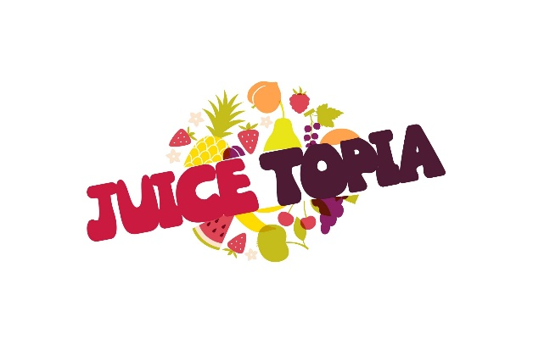
Drink Life
Cleanse Information Packet
Congratulations on your new journey. Whether you are a new or frequent cleanser cheers to you for treating your body. You will be so happy you took this step. (NOTE: DRINK JUICES EVERY 2 HOURS IF POSSIBLE)
FIRST THING:
Pre-Cleanse Prep (1 week of prep is recommended)
-Drink A lot of water! (Very important)
-Eat more fruits and vegetables and less processed foods.
-Avoid Dairy, Sugars, Meat, and Caffeine.
While you are cleansing
-Drink plenty of water in between juices (Stay hydrated)
-Some of the common symptoms
- Headache: can be caused by low blood sugar, withdraw from caffeine and sugars, dehydration, and many more.
- Fatigue: Dehydration can cause this and withdraw from caffeine and sugar.
- Skin irritation: Toxins are being released from the skin, irritation and redness can occur.
- Upset stomach and Flatulence: This may occur as your body is trying to get rid of toxins.

Tips after you complete your cleanse
Try eating raw fruits, vegetables, or nuts. You can also try drinking smoothies as your meals.
-Avoid eating meats, dairy, processed foods, and sugars. These foods are hard for the body to break down. Gradually add them back into your diet if you wish to do so. If you can avoid processed sugars try using natural sweeteners such as dates, unfiltered raw honey (locally grown if available) or organic agave.
-Continue to juice it helps to keep your body energized and your immune system boosted.

Cleanse Options
1 Day Cleanse ($43.50)- Includes 6 16oz juices of your choice.
2 Day Cleanse ($87.00)- Includes 12 16oz juices of your choice.
3 Day Cleanse ($130.50)- Includes 18 16oz juices of your choice.
1 Day Cleanse w/fresh garden salad ($35.50)- (This is best for first timers) -Includes 4 16oz juices and one of our garden salads with choice of non-dairy ranch dressing, honey blossom French dressing, or Raspberry vinaigrette.
Friendly Reminder: This is not called a diet; it is a lifestyle change. At first it can be a challenge but as you continue this journey it will become easier. Avoiding bad foods and incorporating more of a plant-based lifestyle will make you feel great. If you need any assistance, we are here to help. (Disclaimer: This is not intended to diagnose, treat, or cure illness or disease. Always consult your physician about your best treatment or meal plan for your unique requirements).

